**# Venezuela fatoriais**

# onda 3

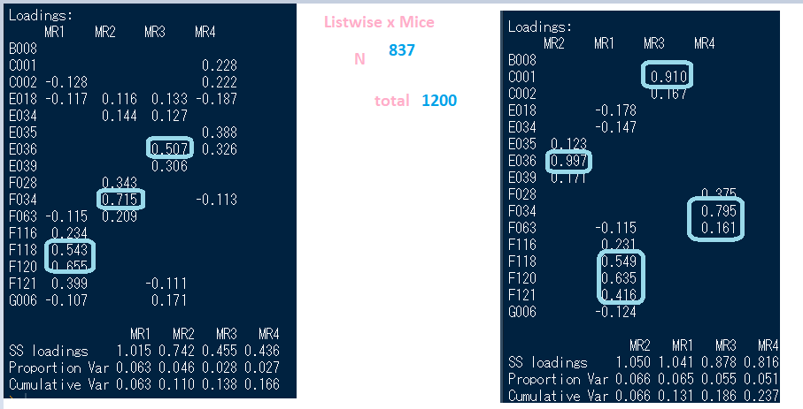

Obs - A imputação não mexeu com E036 – fator interessante

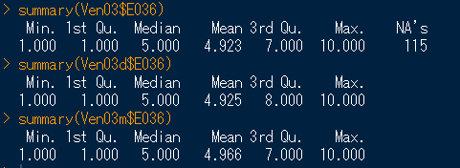

# onda 4

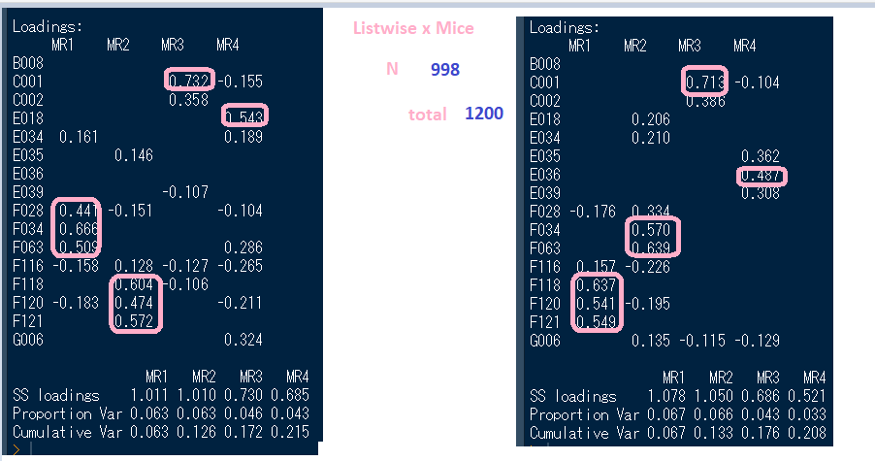

# onda7

|  |  |  |  |  |  |  |  |  |  |  |  |  |  |  |  |  |  |  |  |  |  |  |  |  |  |  |  |  |  |  |  |  |  |  |  |  |  |  |  |  |  |  |  |  |  |  |  |  |  |  |  |  |  |  |  |  |  |  |  |  |  |  |  |  |  |  |  |  |  |  |  |  |  |  |  |  |  |  |  |  |  |  |  |  |  |  |  |  |  |  |  |  |  |  |  |  |  |  |  |  |  |  |  |  |  |  |  |  |  |  |  |  |  |  |  |  |  |  |  |  |  |  |  |  |  |  |  |  |  |  |  |  |  |  |  |  |  |  |  |  |  |  |  |  |  |  |  |  |  |  |  |  |  |  |  |  |  |  |  |  |  |  |  |  |  |  |  |  |  |  |  |  |  |
| --- | --- | --- | --- | --- | --- | --- | --- | --- | --- | --- | --- | --- | --- | --- | --- | --- | --- | --- | --- | --- | --- | --- | --- | --- | --- | --- | --- | --- | --- | --- | --- | --- | --- | --- | --- | --- | --- | --- | --- | --- | --- | --- | --- | --- | --- | --- | --- | --- | --- | --- | --- | --- | --- | --- | --- | --- | --- | --- | --- | --- | --- | --- | --- | --- | --- | --- | --- | --- | --- | --- | --- | --- | --- | --- | --- | --- | --- | --- | --- | --- | --- | --- | --- | --- | --- | --- | --- | --- | --- | --- | --- | --- | --- | --- | --- | --- | --- | --- | --- | --- | --- | --- | --- | --- | --- | --- | --- | --- | --- | --- | --- | --- | --- | --- | --- | --- | --- | --- | --- | --- | --- | --- | --- | --- | --- | --- | --- | --- | --- | --- | --- | --- | --- | --- | --- | --- | --- | --- | --- | --- | --- | --- | --- | --- | --- | --- | --- | --- | --- | --- | --- | --- | --- | --- | --- | --- | --- | --- | --- | --- | --- | --- | --- | --- | --- | --- | --- | --- | --- | --- | --- | --- | --- |
| |  |  |  |  |  |  |  |  |  | | --- | --- | --- | --- | --- | --- | --- | --- | --- | | Não | B006 | Combatting unemployment, we have to accept environmental problems | | | | | |  | | Q111 | B008 | Protecting environment vs. Economic growth | | |  |  |  |  | | Q33 | C001 | Jobs scarce: Men should have more right to a job than women | | | | |  |  | | Q34 | C002 | Jobs scarce: Employers should give priority to (nation) people than immigrants | | | | | |  | | Q45 | E018 | Future changes: Greater respect for authority | | |  |  |  |  | | Q42 | E034 | Basic kinds of attitudes concerning Society | | |  |  |  |  | | Q106 | E035 | Income equality |  |  |  |  |  |  | | Q107 | E036 | Private vs state ownership of business | | |  |  |  |  | | Q109 | E039 | Competition good or harmful | |  |  |  |  |  | | Q171 | F028 | How often do you attend religious services | | |  |  |  |  | | Q173 | F034 | Religous Person? |  |  |  |  |  |  | | Q164 | F063 | How important is God in your life | |  |  |  |  |  | | Q180 | F116 | Justifiable: Cheating on taxes | |  |  |  |  |  | | Q182 | F118 | Justifiable: Homosexuality | |  |  |  |  |  | | Q184 | F120 | Justifiable: Abortion |  |  |  |  |  |  | | Q185 | F121 | Justifiable: Divorce |  |  |  |  |  |  | | Não | F141 | Justifiable: Fighting with the police | | |  |  |  |  | | Q195 | F144_02 | Justifiable: Death penalty | |  |  |  |  |  | | Q254 | G006 | How proud of nationality | |  |  |  |  |  | |  |  |

Nova codificação para Ven07

